Adaptive Coordinated Motion Control with Variable Forgetting Factor for a Dual-arm Space Robot in Post-Capture of a Non-Cooperative Target

**Abstract:** In this paper, a new adaptive coordinated motion control approach with variable forgetting factor is introduced for a dual-arm free-floating space robot. To overcome the problem of dynamics coupling between the space base, its manipulators and the target, we develop a dual-arm space robotic system. One arm is used to complete the capture task and the other is used to counteract the disturbance to the space base. In this case, a new coordinated motion control law is derived based on reaction null space (RNS) control. However, when space robot captures a target satellite, the system may experience output measurement noises and state disturbance, the traditional control methods often achieve poor effect in the practical application. So a recursive least square (RLS) algorithm with variable forgetting factor (VFF) is proposed in this paper to accelerate the convergence rate. Based on momentum conservation, the linear regression form of the estimation problem is obtained, and we further identify the unknown inertial parameters of the target. Finally, the simulation results demonstrate the effectiveness of the proposed algorithm.

Keywords: Coordinated Motion Control, Dual-arm Space Robot, Variable Forgetting Factor, Recursive Least Square Algorithm, Parametric Identification

**Nomenclature**

: The inertia frame

: The end-effector frame

: The rigid body 0, spacecraft

: The link  in arm-k

: The mass centre of link 

: The joint  of arm-k

: The position vector from to  and  to 

: The position vector from  to 

: The position vector of 

: The position vector of the CM of the system

: The position vector of 

: The unit vector for the rotation direction of 

: The linear and angular velocity of spacecraft

: The mass of spacecraft and link 

: The total mass of the system

: The inertia matrix of spacecraft and

: The angle vector of the joints of arm-k

: The attitude angle of the base, expressed in terms of  Euler angles

: The unit matrix

: The Jacobian matrix of arm-k

: The general Jacobian matrix of the system

: The global inertia matrix of the manipulator

: The global inertia matrix of the spacecraft

: The inertia matrix of the space base

: The coupled inertia matrix of the spacecraft and the manipulator

: The angular velocity of the target

: The linear and angular momentum of the spacecraft

: The angular momentum of the target

1. **Introduction**

With the development of astronautic technology, space robots will play an important role in space exploration. Their main missions include capturing and repairing non-cooperative space objects or debris, and supporting astronauts in replacing or assembling components on space stations. Therefore, many countries have paid significant attention to the development of space robotic technologies. The SUMO/FREND project and the Phoenix Program [1] exemplify typical orbital applications of space robots. The main characteristics of the two projects are that the space robots have more than one manipulator and that the inertial parameters of the target spacecraft are much larger than those of the robot.

A number of investigations on the capture of satellites and space debris have been carried out. To describe the interactive relationship between a space robot and the target, researchers in this field generally separate the on-orbit capture missions into four phases [2]: pre-capture, capture (contact), post-capture and compound stabilization. In the pre-capture phase, a space manipulator is controlled and approaches the target by gradually following the motion of the target. At the instant of capture, the end-effector of the space manipulator makes contact with the target until the gripper is closed. The primary challenge in this phase is to minimize the interaction between the end effector and the target. In the post-capture phase, the end-effector of the space manipulator firmly captures the target, and the control strategy have to be developed to deal with the tumbling motion as well as dynamic uncertainties. During the compound stabilization phase, the space robot dampens the motion of the target. The initial angular momentum of the captured target is dampened using thrusters or reaction wheels. In this paper, we address the problems that arise in the post-capture and compound stabilization phase. The main topic that is presented in this paper is minimization of the reaction moment of the space base after capturing a large non-cooperative target satellite that initially has angular momentum. The momentum may cause the system to become unstable. This task is necessary since the antennas of the servicing base must be pointed toward the Earth and, therefore, the base attitude must be maintained.

To resolve the dynamic interaction problems of free-floating robots, a well-known concept of Reaction Null Space (RNS) control law has been widely employed. RNS control law was originally proposed by Nenchev [3] to tackle the problem of base disturbance of a free-floating space robot. Youshida [4] applied the RNS control to stabilize the base attitude in the ETS-VII project, which proved useful. In [2], the Distributed Momentum Control (DMC) strategy was proposed for capturing a tumbling satellite. The RNS motion control was employed to control the joint motion and spacecraft attitude. Recently, based on the RNS control, Huang et al [5] proposed a dynamic balance control algorithm for a dual-arm space robot to plan zero-disturbance end-effector paths. However, most of the approaches mentioned above relies on the accurate dynamic parameters of the target, such as mass and moment of inertia.

In the presence of parameter uncertainties, a wide range of adaptive controller was developed for space robots. After capturing an unknown target, the adaptive techniques were proposed in [6-8] to avoid the effect of parameter uncertainties on the base attitude and achieve trajectory tracking of the end-effector. Thai-Chau and Inna [9, 10] presented an adaptive reaction null space (ARNS) control algorithm to satisfy the objective of maintaining a minimum disturbance to the base, without knowledge of target dynamics. In the proposed adaptive approach, the recursive least squares (RLS) algorithm was employed to update reactionless joint rates for parameter adaptation in online manner. An adaptive filter was used to update the estimated parameters at each time sample. In the classical RLS algorithm, the forgetting factor  is a constant with values between 0 and 1. However, it is unsuitable to track time-varying parameters since the algorithm gain converges to zero, which leads to exponential growth of the filter gain matrix. In order to resolve the conflicts, an improved variable forgetting factor recursive least square (VFF-RLS) algorithm for ARNS approach is developed by incorporating on-line estimation and adaptive control into a dual-arm space robotic system. This algorithm can avoid the covariance explosion problem arising in the RLS algorithm with constant forgetting factor. In this case, past data are gradually discarded on the assumption that more recent data are more informative.

To resolve the problem of parameter uncertainties, another strategy is to identify the uncertain parameters. A typical two-stage approach was introduced in [11-13], which involved first estimating the uncertain parameters and then designing a controller with the estimated parameters. In these articles, methods were proposed to identify the inertial parameters of a target handled by a space manipulator. These authors derived a parameter identification procedure from the momentum conversation equations, which is known as DMC and is unique to space manipulator systems. The great challenges of this strategy is that it is difficult to find an appropriate linear expression for the case of tumbling target. In this study, we skillfully obtain a linear expression with respect to the uncertain parameters. Based on this expression, the parameter identification task is performed online while the manipulators are executing ARNS motion.

~~With the developed dual-arm space robot system, an extension of the ARNS algorithm is presented with VFF-RLS. The ARNS scheme is reformulated and integrated with the target’s parameter identification procedure, where the recursive least squares (RLS) algorithm is implemented.~~ ~~To improve the stability and accelerate the convergence rate of the tracking errors, a VFF-RLS algorithm is developed. The variable forgetting factor plays an important role in the behavior of the RLS algorithm in terms of convergence and stability.~~

The principal differences of the proposed algorithm from previous related studies can be stated as follows:

1. The ARNS motion control scheme is expanded from a single-arm space robot to a dual-arm space robot, in which both arms execute ARNS motion. This adaptive scheme is employed to stabilize a non-cooperative target that carries unknown momentum without the use of reaction wheels or jet thrust;
2. In the presence of parameter uncertainties, a VFF-RLS algorithm is implemented, which can improve the stability and accelerate the convergence rate of the tracking errors;
3. Based on momentum conversation, we obtain the linear regression form of the estimation problem. The identification procedure is formulated for the case of the tumbling target with an unknown initial angular momentum;

This paper is organized as follows. Section II describes the kinematic modeling and coordinated motion equation of a dual-arm, free-floating space robot. Then, the ARNS algorithm for a dual-arm space robot is reformulated with a variable forgetting factor. Next, the estimation algorithm for the identification of the inertial parameters is presented. Next, a convergence analysis of the algorithm is conducted. The proposed method is validated with some simulation examples in Section VI. Section VII provides the conclusions and recommends directions for future work.

1. **Dual-arm Space Robot System**
   1. **Basic Assumptions**

During the operation, the space robot is in free-floating mode. We assume that:

1. The system is composed of rigid bodies only, and the origin of the inertial frame is located at the center of mass of the entire system.
2. After the manipulator grasps the target, the target is fixed to the end-effector; thus, there is no relative linear motion between the end-effector and the target.
3. The initial linear and angular momenta of the space robot system is zero.
4. No external forces or torques are exerted on the entire system (space robot and target). The reaction wheels or other momentum exchange devices are not considered in this article. The total momentum of the system is conserved in this situation.
   1. **Kinematic Modelling of a Dual-arm Space Robot**

The dual-arm space robot consists of a space base (spacecraft) and two arms. One arm is the mission arm (arm-a), which is used to complete space tasks, such as capturing and assembling; the other arm is known as the balance arm (arm-b), which is used to compensate for the reaction motion of the mission arm, as shown in Figure 1.

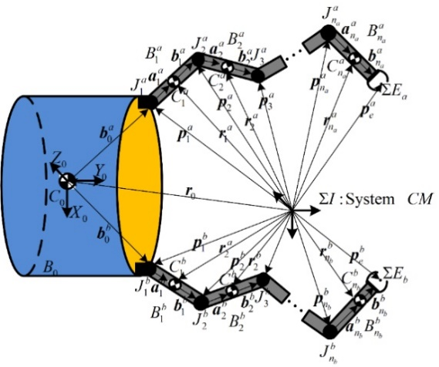

Figure 1. Dual-arm Space Robot System

An alternative approach to establish the model of a dual-arm space robot is described in [14]. From Figure 1, the position of body  and end-effector in arm-k ( ) are, respectively, as





Differentiating the two sides of Eq. and , the linear and angular velocities equation are obtained:









Under Assumption (d), the total momentum of the space robot system is conserved, implying that the linear and angular momentum of the space systemremains constant. The elements of the matrix are explicitly described in [14]:







where  is defined as the skew-symmetric matrix of the vector . Combining Eq. and into a compact form, we obtain



Then, Eq. can be rearranged as



where



and .



The linear velocity of the base can be cancelled out by the first three rows of Eq.; then, the angular momentum conservation equation can be written as



With Assumption (c), there is no initial angular momentum  and no attitude disturbance :



In this dual-arm space robot system, arm-a is designed to accomplish the capture task, and arm-b is used to compensate for the attitude disturbance due to the motion of arm-a; thus, the mapping relationship between the two arms can be formulated. The trajectory of the balance arm is generated by that of the mission arm:



where  is the standard pseudo inverse of matrix .

From the Eq. and Eq. , specifically under ideal conditions, the null-space solutions for the joint rates of arm-a and arm-b can be obtained as





where,  are two arbitrary vectors with units of angular rates. The matrix  is the linear projection operator onto the null-space of.

For the general case in which the initial system angular momentum is non-zero and the tumbling target has angular momentum , Eq. can be restated as follows:



where  is the angular momentum of the space robot before capture. The matrix include the inertia term of the target by assuming that the target is rigidly attached to the end-effector. Then according to the generalization of Eq. and , the RNS motion for the manipulators to produce zero attitude disturbance to the base can be computed as





where  is the angular momentum of the entire system after capture and  denotes the required reactionless joint rates of arm-k. However, in the absence of accurate knowledge of  due to the unknown properties of the target, the general solution for the joint rates can be written as





Substituting for and from Eq. and into and respectively, yields





Clearly, the expressions of Eq. and are of the same form; thus, they can be rewritten as follows:



where



The motion generated by Eq. does not cause any rotational motion of the base. Since the matrix  is always invertible and assuming has a full row rank, Eq. can be rewritten as



or, more succinctly,



where .

Thus, Eq. is the foundation of the ARNS control scheme for a dual-arm space robot system. From this regression form of Eq. , it can be viewed that if the joint rates  closely follows the desired RNS joint rates ,  may converge to zero, which means that zero attitude disturbance to the base is produced. In the ARNS control scheme, Eq. is coupled with the VFF-RLS algorithm for parameter adaption.

1. **Recursive Adaptation Algorithm with Variable Forgetting Factors**

If perfect knowledge of the system properties is available, Eq. can be considered as an alternative to compute the RNS motion. However, to capture a non-cooperative target, the mission will involve an unpredictable change in the inertia properties, as well as the total momentum of the system. When there are parameter uncertainties in the system, one way to reduce the uncertainty is to use adaptive control algorithm. In the system identification context, the RLS algorithm with variable forgetting factor is employed to adaptively update the joint rates in online manner.

~~In this section, the ARNS algorithm is expanded from a single-arm space robot [3, 9, 10] to a dual-arm space robot, where an adaptive coordinated motion control of the dual-arm space robotic system is constructed to minimize the disturbance transferred to the base.~~

The time-varying system commonly can be represented by a linear regression equation, i.e. Eq. , which is the foundation of the ARNS control scheme for a dual-arm space robot system. Since the captured target changes the dynamic properties of the arm in an undetermined way, the reference joint rate  in Eq. is redefined as



where  and  are the joint rates and base angular velocity measured by the sensors, respectively.  is the output error vector.  is defined to present the unknown variables of the non-cooperative target.

As per [9, 10], using the base angular velocity and joint rates at time t, the VFF-RLS approach is employed to compute the updates for:









where the time index is introduced to describe the discrete nature of the process in a practical control system.  is the Kalman filtering gain vector,  is the estimation covariance matrix and  is the variable forgetting factor. With the estimates and the exact measurements of  and ,  is defined as the prediction error.  The initial value of the gain matrix , can be set as  for .

The VFF-RLS algorithm results from the following optimization problem. Given  and , determine minimization of the following quadratic cost function:



Where  can be expressed as a quadratic form as follows:





The idea of this algorithm is to emphasize artificially the effect of current data by exponentially weighting past data values, since while space robot is grasping the target, huge impact may happen, which will result in measurement errors in the sensors. Since the sequence  has the effect of attaching smaller weight to those terms in which  is expected to have larger errors, the algorithm is frequently used in the case of time-varying systems. Another use of the sequence  is to discard initial data in nonlinear estimation problems. The bad initial data may deteriorate the performance of the algorithm unless it is discarded once the algorithm is under way.

In the articles [9, 10], a constant forgetting factor is employed, but problems can occur in an adaptive control situation. Since the matrix changes with time, matrix  may become excessively large or approach zero.  needs to be reset to its initial value whenever it surpasses the preset thresholds; otherwise, the parameter estimator can go unstable.

To overcome this problem, the idea of exponential data weighting with variable forgetting factor is employed. It has been shown in [15] that a good choice for  in such cases is



where  is the prediction error,  is the mean value of over a certain period, and  is a small constant. Based on the knowledge of Kalman filtering theory [16], it can be shown that  is proportional to  and hence Eq. can be rewritten as



Unlike the conventional variable forgetting factor schemes, the proposed VFF-RLS control scheme is based on the prediction errors. The effect of the choice on the algorithm Eq. and Eq. can be explained as follows. If a sudden change in the control system occurs,  increases; this reduces  temporarily but increases  quickly so that rapid adaptation can occur. After adaptation  decreases, returns to a value near 1. Thus the cycle will repeat itself.

Hence, the new VFF-RLS algorithm can be obtained by Eq. – Eq.. The new VFF-RLS has higher numerical stability and faster convergence than the conventional RLS algorithm in [9, 10].

Once  is calculated, the desired ARNS motion of the arms can be obtained:



1. **Parameter Identification of a Large Non-cooperative Target**

In the previous section, the ARNS scheme is proposed based on VFF-RLS algorithm as a means to transition from post-capture phase to compound stabilization phase, thus providing a buffer in time during which the base is undisturbed. In this section, the momentum-based parameter identification for the unknown target is formulated, while the arms are executing the ARNS motion. In the following derivation, it is assumed that shortly after the manipulator grasps the target, the target is fixed to the end-effector, and hence the inertial parameters of the last link of arm-a are altered (see Figure 2). Under this assumption, the unknown parameters to be identified are the mass, the position of the centre of mass and the inertia moment [17].

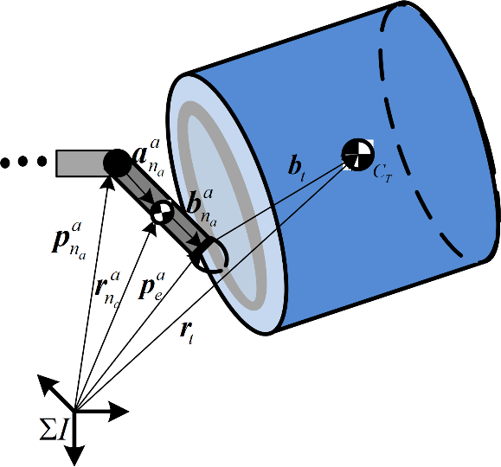

Figure 2. Part of a target captured by the space robot

After capturing the target, the linear and angular momentum equations, Eq. and Eq. , are rewritten by involving the unknown parameters of the non-cooperative target:





where  is the angular velocity of the target (with ) and  is the position vector of the mass center of the target to the origin of inertia coordinate, which can be decomposed as





where  is the rotation matrix from frame  to . Substituting for  and  from Eq. and Eq. , separating the terms that involve the parameters to be identified at time  and ,  and  can be rewritten as





Since the momentum of the entire system is conserved, the increment of the total momentum, as the system evolves from the configuration at time  to another configuration at the instant  is zero. This process results in the following:





If  tends to an infinitely small value, , then Eq. can be simplified as



In Eq. -,  and  denotes the increment of the linear and angular momentum between time  and . Combining Eq.- into matrix form and factoring out the vector of unknown parameters, the standard linear equation for the estimation problem is obtained as follows:



where



After the target is fixed to the end-effector, the angular velocity  is equal to .  can be calculated in real time.

After the linearization, the dynamic parameters needed to be solved are described in body-fixed frame of the target and they are constant in each state, which is convenient to process and analyze the subsequent data.

The kinematic parameters of each component, which are obtained from the system dynamics model established by the previous recursive method, are brought into the identification model, and then all the inertial parameters can be calculated through the least square method.

The proposed ARNS scheme with variable forgetting factor requires measurements of the base angular velocity and the current joint rates. To compute the variable forgetting factor in Eq., the current prediction error  is also required. The process of the complete algorithm is presented in Figure 3, and the following primary steps are obtained:

* Step 1. Initialize the system based on pre-capture parameters , , 
* Step 2. Measure , and 
* Step 4. Compute  from Eq. – Eq..
* Step 5. Using, update the desired motion from Eq.
* Step 6. Compute  from Eq.
* Step 7. , return to step 2 until finished

In this way, the parameter matrix  and the ARNS joint rates are updated, and certain relevant problems are resolved simultaneously: maintaining the base attitude and identifying the unknown inertial parameters of the tumbling target.

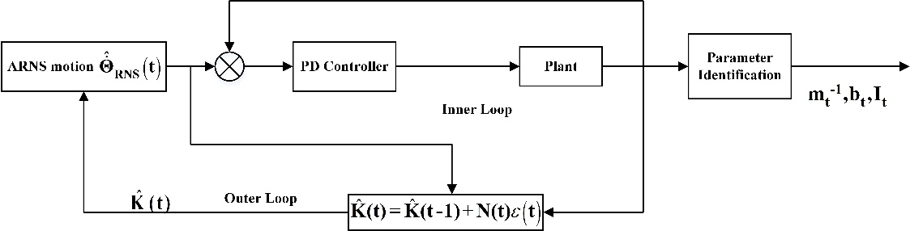

Figure 3. ARNS control scheme with estimation of inertia parameters

1. **Convergence Analysis**

Following the proposed approach to deal with a time-varying system, the convergence properties are discussed in this section. A non-negative Lyapunov function  is defined as



Using -, we have



From Eq. and Eq. , we obtain



The difference of  is given by



Inserting Eq. and Eq. to Eq. gives



Recall that  and  is a positive definite matrix and  is the maximum eigenvalue of the matrix, which is bounded, i.e.



It is clear that  is a non-negative, non-increasing function and hence it converges. Thus, we have



It is clear from the equations above that  will converge to zero. This is a desirable property and tends to improve the robustness of the algorithm.

1. **Simulation Study**

The simulation study aims to verify the capability of the proposed adaptive coordinated motion control scheme with variable forgetting factor to minimize the disturbance to the base. The verification is presented using a dual-arm planar space robot; each arm has 3 degree of freedom. The target is realistically captured by the manipulator, and the target is assumed to be firmly held by the gripper mechanism as illustrated in Figure 4.

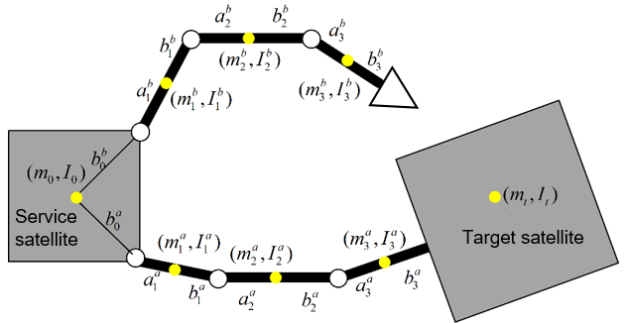

Figure 4. Dual-arm space robot with captured target

The dynamic model of the space robot and the target are created in MATLAB/SimMechanics with S-Functions. The relevant parameters of the base, links and initial states employed in this study are summarized in Table 1 and Table 2. Especially, the non-cooperative target is much larger than the space robot. The mass and inertia are assumed to be four times as large as the mass and inertia of the servicer (refer to Table 3).

|  |  |  |  |  |  |  |  |  |  |  |  |  |  |  |  |  |  |  |  |  |  |  |  |  |  |  |  |  |  |  |  |  |  |  |  |  |  |  |  |  |  |  |  |  |  |  |  |  |  |  |  |  |  |  |  |  |  |  |  |  |  |  |
| --- | --- | --- | --- | --- | --- | --- | --- | --- | --- | --- | --- | --- | --- | --- | --- | --- | --- | --- | --- | --- | --- | --- | --- | --- | --- | --- | --- | --- | --- | --- | --- | --- | --- | --- | --- | --- | --- | --- | --- | --- | --- | --- | --- | --- | --- | --- | --- | --- | --- | --- | --- | --- | --- | --- | --- | --- | --- | --- | --- | --- | --- | --- |
| Table 1. Parameters for dual-arm space robot   |  |  |  |  |  |  | | --- | --- | --- | --- | --- | --- | | Symbol | Mass (kg) | Length(m) | | Inertia | | |  |  | |  | |  | 44 | 0 | 0.3 | | 44 | |  | 2.5 | 0.2 | 0.2 | | 0.21 | |  | 2.5 | 0.2 | 0.2 | | 0.21 | |  | 2.5 | 0.2 | 0.2 | | 0.21 | |  | 2.5 | 0.2 | 0.2 | | 0.21 | |  | 2.5 | 0.2 | 0.2 | | 0.21 | |  | 2.5 | 0.2 | 0.2 | | 0.21 | | Table 2. Initial state for dual-arm space robot   |  |  |  | | --- | --- | --- | |  | Angle (deg) | Angular velocity(deg/s) | | Arm-a | [45,-45,-10] | [0, 0, 0] | | Arm-b | [-20,20,10] | [0, 0, 0] | |
| Table 3. Parameters for non-cooperative target   |  |  |  |  |  | | --- | --- | --- | --- | --- | |  | Mass (kg) | Length (m) | Inertia | Angular  velocity | |  |  |  |  | | Target | 120 | 0.3 | 120 | 1.15 | |

The space manipulator initially has no momentum, and the target is tumbling with an initial angular velocity. The initial adaptation gain matrix is defined as . The initial forgetting factor for the RLS algorithm is ; it will be reset when  or . The step size is.

Case A: Accuracy Test Case

Before the estimation of the parameter, the accuracy of the simulation platform is first ascertained by examining the momentum conservation of the system during the ARNS motion. In this case, the forgetting factor is fixed and is. This scenario demonstrates the adaptation of ARNS in producing the reaction null-space motion when the inertia parameters of the space manipulator are modified as a result of target capture. In Figure 5 (a logarithmic (base 10) scale is used for the X-axis, t=20s), the system angular momenta are illustrated, depicting the process of the angular momentum distribution as the total angular momentum remains zero. The process of the distribution is slow because the target is much larger than the space robot. Figure 6 shows the ARNS motion control maintaining the base attitude while one arm holds the large non-cooperative target. When the capture happens, we can observe that the impact produces a significant rate disturbance (as high as 0.011 deg/s) and then minimum base disturbance is produced by ARNS motion. In Figure 7 and Figure 8, the corresponding results are shown, which one can observe the joint motions and the convergence of the joint rates. These results verify the accuracy of the simulation platform and its suitability for testing the proposed control concept.

|  |  |
| --- | --- |
| C:\Users\Chunting\Documents\MATLAB\ARNSC_identify_DYN_para_4\data\2018_07_01_10_54\AngularMomentum.jpg  Figure 5. Angular momentum of the system | C:\Users\Chunting\Documents\MATLAB\ARNSC_identify_DYN_para_4\data\2018_07_01_10_54\BaseDisturbance.jpg  Figure 6. Base response: angular attitude and velocity |

|  |  |
| --- | --- |
| C:\Users\Chunting\Documents\MATLAB\ARNSC_identify_DYN_para_4\data\2018_07_01_10_54\JointVelcity.jpg  Figure 7. Joint rates with fixed forgetting factor | C:\Users\Chunting\Documents\MATLAB\ARNSC_identify_DYN_para_4\data\2018_07_01_14_28\JointAngular_Error.jpg  Figure 8. Joint rates error with fixed forgetting factor |

The results for the ARNS algorithm without variable forgetting factor that are presented here demonstrate the important role of the proposed ARNS scheme in the post-capture phase. Once the capture is established, the momentum-based parameter identification method is executed. The motions generated by the ARNS scheme provide the measurements required for solving the parameter identification problem stated in Eq. . The estimation results are shown in Figure 9 and Table 4. Around 0.1s after capture, the parameter estimates for, and, converge to their real values. The availability of inertial parameters for the entire base-manipulator-target system facilitates the post-capture stabilization task, since precise knowledge of space manipulator dynamics is necessary for many model-based control algorithms, such as trajectory control, optimal control or distributed momentum control.

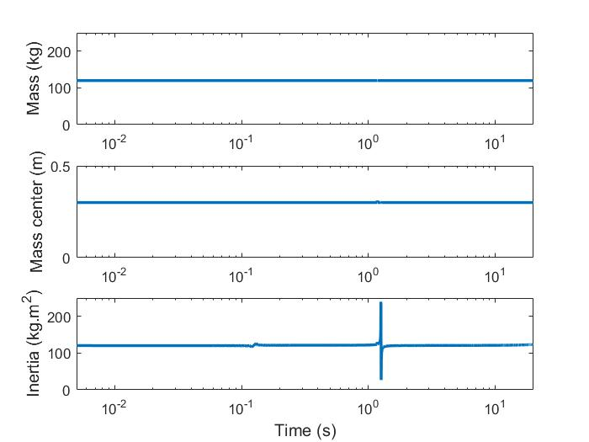

Figure 9. Estimations of inertial parameters

Table 4. Estimations of inertial parameters

|  |  |  |  |
| --- | --- | --- | --- |
|  | Mass (kg) | Length (m) | Inertia(kg·m2) |
|  |  |  |
| Target | 119.9998 | 0.3000 | 120.0004 |

Case B: ARNS motion with VFF-RLS algorithm

In this subsection, the improved VFF-RLS algorithm is tested by simulating the capture of a tumbling target. As in the previous simulations, we assume that the target is attached rigidly to the last link after capture and its tumbling motion is emulated with an external impulse torque of 96 Nm applied to the end effector for the duration of 0.005 second. The initial forgetting factor for the RLS algorithm is also. In this simulation, the actual capture occurs at t=0.01s. The corresponding results for the VFF-RLS algorithm are shown in Figure 10 - Figure 14.

Figure 10 presents the joint rates, from which one can observe that the arms are initialized at the instant of capture with rates  computed from Eq. and the ARNS adaptively updates the reactionless motion. As can be seen from Figure 11, the capture creates an initial angular disturbance on the base. This disturbance, however, is successfully reduced with the ARNS motion to the level of  within 2 second after capture. As well, Figure 12 and Figure 13 present the convergence of the algorithm. Figure 12 is the relationship between the reference joint rate  and actual joint rate  and it is clear from Figure 13 that  will converge to zero. We are going to talk about more details about the convergence properties in next section. Figure 14 shows the forgetting factor curves. When space robot captures the target, the algorithm gets the small forgetting factor to discard the estimation because of the big error. These initial data may deteriorate the performance of the algorithm unless it is discarded once the algorithm is under way. Later, it increases the forgetting factor to attach more recent data to the nonlinear estimation problems, which can speed convergence and improve system stability. Finally, the forgetting factor converges to 1, and the algorithm deteriorates to the well-known standard least squares algorithm. In Figure 15, one can observe that within 5 iterations after capture, the parameter estimates for,  and converge to their real values.

|  |  |
| --- | --- |
| C:\Users\Chunting\Documents\MATLAB\ARNSC_identify_DYN_para_4\data\2018_07_03_21_40\JointVelcity.jpg  Figure 10. Joint rates with VFF-RLS | C:\Users\Chunting\Documents\MATLAB\ARNSC_identify_DYN_para_4\data\2018_07_03_21_40\BaseDisturbance.jpg  Figure 11. Disturbance to the base with VFF-RLS |
| C:\Users\Chunting\Documents\MATLAB\ARNSC_identify_DYN_para_4\data\2018_07_03_21_40\JointAngular_Error.jpg  Figure 12. Joint rates error with VFF-RLS | C:\Users\Chunting\Documents\MATLAB\ARNSC_identify_DYN_para_4\data\VFF\K_Error.jpg  Figure 13. Convergence of the matrix  with VFF-RLS |
| C:\Users\Chunting\Documents\MATLAB\ARNSC_identify_DYN_para_4\data\2018_07_03_21_40\Lamda.jpg  Figure 14. Variable forgetting factor in ARNS | C:\Users\Chunting\Documents\MATLAB\ARNSC_identify_DYN_para_4\data\2018_07_03_21_40\IdentificationResult.jpg  Figure 15. Estimations of inertial parameters |

Case C: Convergence Analysis

For evaluating the performance of the proposed VFF-RLS algorithm, we compare the classical RLS algorithm with different constant values of the forgetting factor with the improved VFF-RLS algorithm. The forgetting factors are set to ,,, respectively. Other initial parameters are the same with previous simulation in *case B.* The results are presented in Figure 16-Figure 21 and the relevant results of the improved VFF-RLS have been shown in *case B*, Figure 11 and Figure 13. According these results, several remarks can be outlined, as follows. First, it can be noticed that all the algorithms are able to achieve the convergence properties despite the value of the forgetting factor. However, problems can occur with constant value of .In this situation, this can result in “burst” phenomena in parameter estimates, which occur at around 2nd second in Figure 16 and 4th second in Figure 17. This can be explained as below. ~~If the data are not persistently exciting. This leads to exponential growth of the  matrix.~~

Initially, with poor parameter estimates (within the first 0.1 second), the resulting feedback will lead to bad regulation and hence the data will be rich in information. Then as the estimates converge, the system under feedback tends to settle down, but simultaneously the estimation covariance matrix  begins to grow due to the loss of persistent excitation. After some time, the parameter estimator can go unstable since  appears as a gain in the algorithm. This can give rise to poor estimates and resulting feedback controller will begin perform badly. However, in Figure 18, even though the “burst” phenomena does not happen, compared to the RSL-VFF in Figure 13, it takes more time to converge. The proposed VFF-RLS algorithm obtains good performance within 0.02 second in Figure 13, but it takes 0.2 second to converge in Figure 18 when . From Figure 11 and Figure 19-Figure 21, in terms of the disturbance to the base, the proposed VFF-RLS also outperforms the other algorithms, which can be seen in Table 5, the absolute value of the maximum disturbance to the base.

|  |  |  |
| --- | --- | --- |
| C:\Users\Chunting\Documents\MATLAB\ARNSC_identify_DYN_para_4\data\Lamda\K_Error_09.jpg  Figure 16. Convergence of the matrix  with RLS, | C:\Users\Chunting\Documents\MATLAB\ARNSC_identify_DYN_para_4\data\Lamda\K_Error_099.jpg  Figure 17. Convergence of the matrix  with RLS, | C:\Users\Chunting\Documents\MATLAB\ARNSC_identify_DYN_para_4\data\Lamda\K_Error_0999.jpg  Figure 18. Convergence of the matrix  with RLS, |
| C:\Users\Chunting\Documents\MATLAB\ARNSC_identify_DYN_para_4\data\Lamda\BaseDisturbance_09.jpg  Figure 19. Disturbance to the base with RLS, | C:\Users\Chunting\Documents\MATLAB\ARNSC_identify_DYN_para_4\data\Lamda\BaseDisturbance_099.jpg  Figure 20. Disturbance to the base with RLS, | C:\Users\Chunting\Documents\MATLAB\ARNSC_identify_DYN_para_4\data\Lamda\BaseDisturbance_0999.jpg  Figure 21. Disturbance to the base with RLS, |

Table 5. Absolut value of the maximum base angular attitude and velocity

|  |  |  |
| --- | --- | --- |
|  | Angular attitude | Angular velocity |
|  | 0.4704 | 0.0639 |
|  | 0.0070 | 0.0086 |
|  | 0.0020 | 0.0086 |
| VFF | 0.0008 | 0.0038 |

1. **Conclusion**

This paper has presented a practical implementation of RLS algorithm with variable forgetting factor for a dual-arm space robot capturing task. In the course of on-orbit servicing, the tumbling target was assumed to be much larger than the space robot, which meant that the uncertainties of the inertia properties of the target would degrade the control performance and the compound stabilization. To address this problem, the ARNS algorithm is extended to dual-arm space robot and is enhanced by incorporating the VFF-RLS technique and is used to carry out the on-line parameter estimation and updating. The novelty of the proposed VFF-RLS algorithm lies in the time-varying function of determining the forgetting factor, as well as relating the forgetting factor to the prediction error in the estimated parameters. The convergence properties of this algorithm were analysed. Simulation results have revealed the good performance of the proposed algorithm for both maintaining minimum disturbance to the base and accelerating the convergence rate of the tracking errors. We remark that the proposed methods are applicable to a dual-arm space robot supplying on-orbit services.

**Acknowledgements**

This work has been supported by the Tsinghua National Laboratory for Information Science and Technology, Shenzhen Key Lab of Space Robotic Technology and Telescience, and the Natural Science Foundation of Guangdong (No. 2015A030313881).

**References**

[1] T. Debus and S. Dougherty, "Overview and Performance of the Front-End Robotics Enabling Near-Term Demonstration (FREND) Robotic Arm," in *AIAA Infotech@Aerospace Conference*, 2009.

[2] D. N. Dimitrov and K. Yoshida, "Momentum distribution in a space manipulator for facilitating the post-impact control," in *2004 IEEE/RSJ International Conference on Intelligent Robots and Systems (IROS) (IEEE Cat. No.04CH37566)*, 2004, vol. 4, pp. 3345-3350 vol.4.

[3] D. N. Nenchev, K. Yoshida, P. Vichitkulsawat, and M. Uchiyama, "Reaction null-space control of flexible structure mounted manipulator systems," *IEEE Transactions on Robotics and Automation,* vol. 15, no. 6, pp. 1011-1023, 1999.

[4] K. Yoshida, K. Hashizume, and S. Abiko, "Zero reaction maneuver: flight validation with ETS-VII space robot and extension to kinematically redundant arm," in *Proceedings 2001 ICRA. IEEE International Conference on Robotics and Automation (Cat. No.01CH37164)*, 2001, vol. 1, pp. 441-446 vol.1.

[5] H. Panfeng, X. Yangsheng, and L. Bin, "Balance control of multi-arm free-floating space robots during capture operation," in *2005 IEEE International Conference on Robotics and Biomimetics - ROBIO*, 2005, pp. 398-403.

[6] S. Abiko and K. Yoshida, "Adaptive Reaction Control for Space Robotic Applications with Dynamic Model Uncertainty," *Advanced Robotics,* vol. 24, no. 8-9, pp. 1099-1126, 2010/01/01 2010.

[7] S. Xu, H. Wang, D. Zhang, and B. Yang, "Adaptive Reactionless Motion Control for Free-Floating Space Manipulators with Uncertain Kinematics and Dynamics," *IFAC Proceedings Volumes,* vol. 46, no. 20, pp. 646-653, 2013/01/01 2013.

[8] P.-C. Cong, Y. F. Lan, and X. Zhang, "Adaptive control of dual-arm space manipulator capturing object," *Proceedings of the Institution of Mechanical Engineers, Part G: Journal of Aerospace Engineering,* vol. 227, no. 6, pp. 992-999, 2013/06/01 2012.

[9] T. C. Nguyen-Huynh and I. Sharf, "Adaptive reactionless motion for space manipulator when capturing an unknown tumbling target," in *2011 IEEE International Conference on Robotics and Automation*, 2011, pp. 4202-4207.

[10] T. C. Nguyen-Huynh and I. Sharf, "Adaptive ReactionLess motion with joint limit avoidance for robotic capture of unknown target in space," in *2012 IEEE/RSJ International Conference on Intelligent Robots and Systems*, 2012, pp. 1155-1160.

[11] C. G. Atkeson, C. H. An, and J. M. Hollerbach, "Estimation of Inertial Parameters of Manipulator Loads and Links," *The International Journal of Robotics Research,* vol. 5, no. 3, pp. 101-119, 1986.

[12] Y.-H. Jia, Q. Hu, and S.-J. Xu, "Dynamics and adaptive control of a dual-arm space robot with closed-loop constraints and uncertain inertial parameters," *Acta Mechanica Sinica,* journal article vol. 30, no. 1, pp. 112-124, 2014.

[13] K. Yoshida and S. Abiko, "Inertia Parameter Identification for a Free-Flying Space Robot," in *AIAA Guidance, Navigation, and Control Conference and Exhibit*(Guidance, Navigation, and Control and Co-located Conferences: American Institute of Aeronautics and Astronautics, 2002.

[14] K. Yoshida, R. Kurazume, and Y. Umetani, "Dual arm coordination in space free-flying robot," in *Proceedings. 1991 IEEE International Conference on Robotics and Automation*, 1991, pp. 2516-2521 vol.3.

[15] G. C. Goodwin and K. S. Sin, *Adaptive Filtering Prediction and Control*. Dover Publications, Inc., 2009, p. 560.

[16] C. Paleologu, J. Benesty, and S. Ciochină, "A practical variable forgetting factor recursive least-squares algorithm," in *2014 11th International Symposium on Electronics and Telecommunications (ISETC)*, 2014, pp. 1-4.

[17] S. Jianjun, D. Xiaoping, W. Chao, W. Qiao, L. Xin, and J. Yu, "Mass Characteristic Parameter Identification for a Space Robot Based on Angular Momentum Conservation," in *2011 International Conference in Electrics, Communication and Automatic Control Proceedings*, R. Chen, Ed. New York, NY: Springer New York, 2012, pp. 333-340.